How to Enter Payment to a Subscription, Create a Temporary Stops, Missed Paper Credits, Note to the Driver
- Click Subscription from the Menu Bar.

- Enter starting characters to any one of the search criteria, then click search,
click Select from the List of Subscriber to display the subscription details
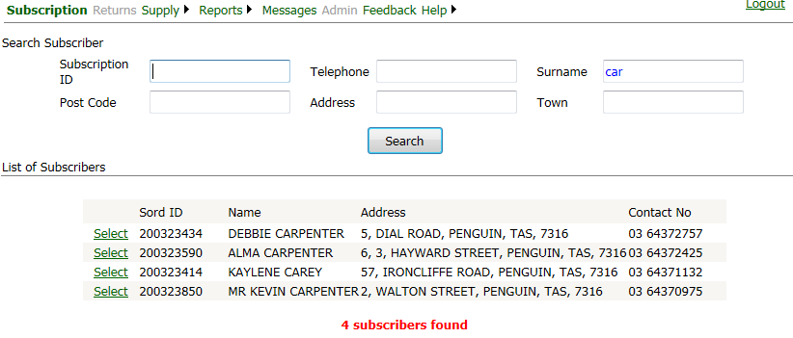
You could enter the Subscription ID and click Search to go directly to the Subscription Details
- On the Enter New Payment, calculate the amount due up to a certain date, or just enter the payment amount by clicking Pay Fixed Amount, then click Accept Payment
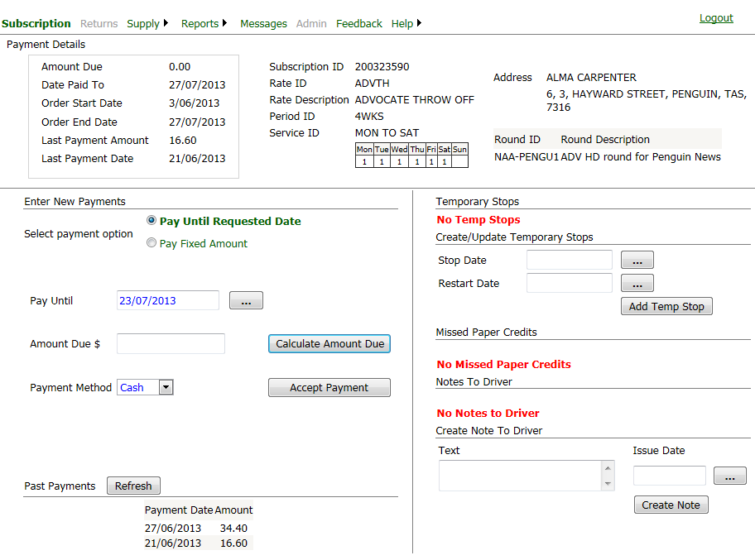

- Create Temporary Stop
Specify the Stop Date and the Restart Date by click the button with the 3 ellipses, then click Add Temp Stop button

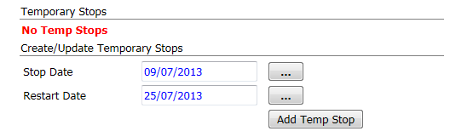

- Update existing temp stop
Select temp stop to update by ticking the check box, change either the stop date or start date, then click Update Temp Stop button
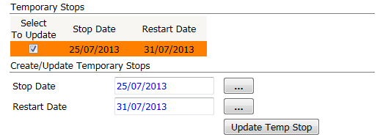

- Create note to the driver
Enter the note text, issue date and click Create Note button
