How to Enter Returns
- Click Returns from the Menu Bar.
- Enter returns, Click Submit Returns.
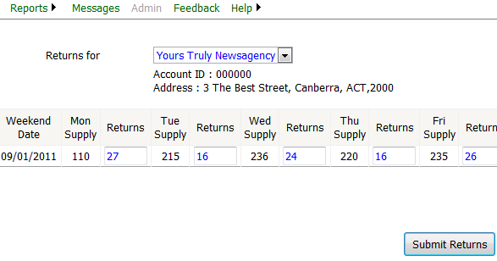
Enter returns
Click this button to record returns
- Returns entered will be recorded and a Returns File Reference will be displayed.

How to print Returns Receipt Report
- Click the Print Receipt Button.

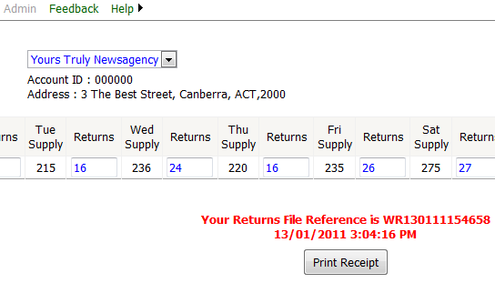
Click this button to print returns receipt

- Click Print Button.

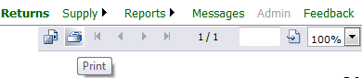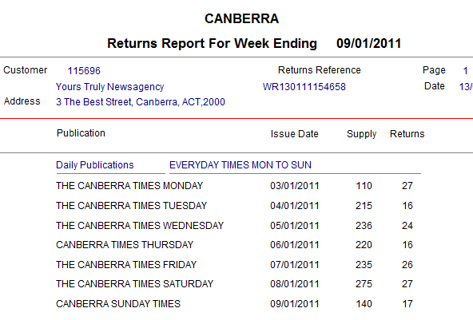
000000
Your Newspaper Monday

Your Newspaper Tuesday

Your Newspaper Wednesday

Your Newspaper Thursday

Your Newspaper Friday

Your Newspaper Saturday

Your Newspaper Sunday
- Click Ok Button.

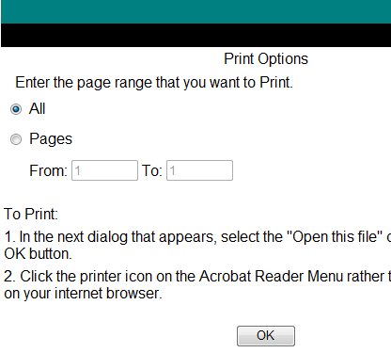

- Click Print Button.

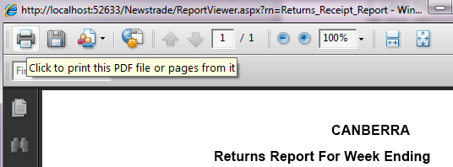

- Select the Printer Name, Click Ok Button.

