You are allowed to edit supply from Monday up to Friday 12:00 noon.
How to Edit Supply?
- Click Supply, then Edit Supply from the Menu Bar.
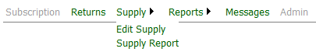
- Click the drop down arrow to select week commencing. Click Edit button.
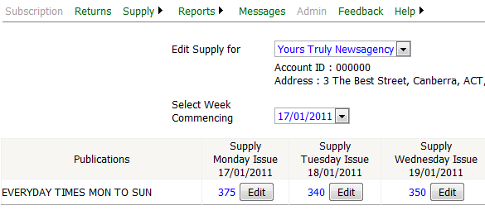
Click drop down arrow to select week commencing
Click Edit Button to change supply
- Change Casual Sales Supply. Leave This Issue selected if you intend to update only this issue.
Selecting All Tue Issues will update the supply for all future Tue issues including This Tue Issue.
Enter Reason, then Click Submit to record requested change.
Cancel will give you to option to start again.
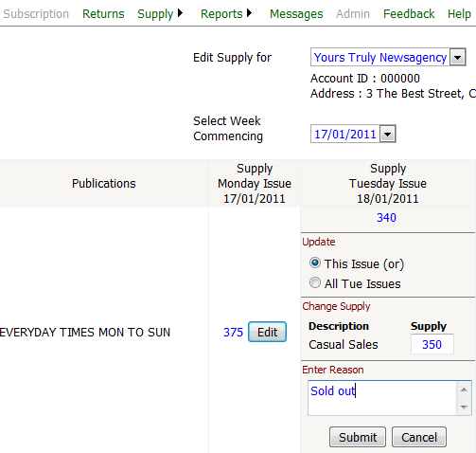
Click Submit to record new supply. Cancel to discard changes.
Enter new supply
Leave This Issue selected if you intend to update only this issue

- After clicking Submit, a pending approval message will be displayed.
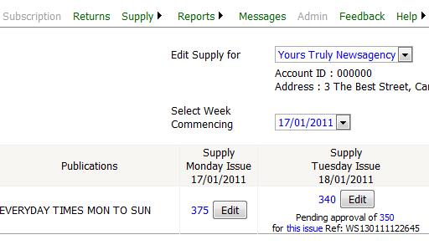
Pending approval message
- An approval message will be displayed, confirming the supply change.
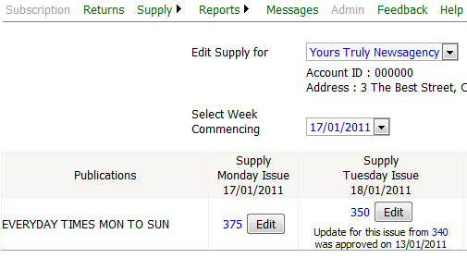
Message confirming supply change is approved

